RC2040 connected to USB, Serial set to USB

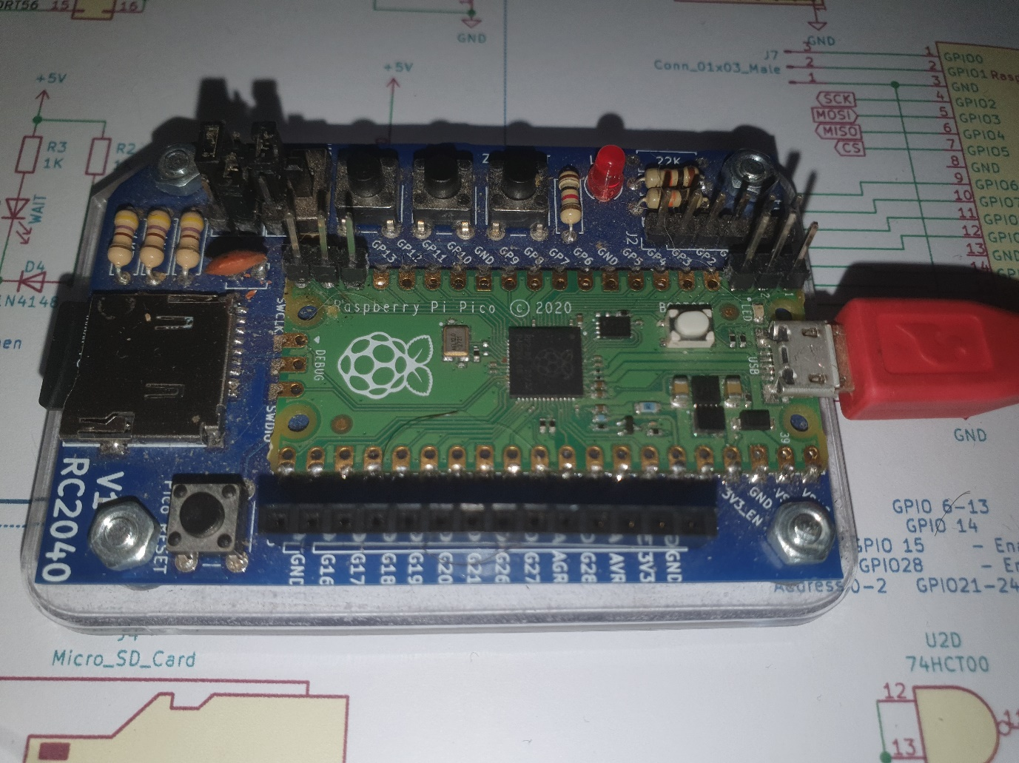

Connect to (in this case COM4) with Terminal Emulator (Terraterm)

Press BUT button on RC2040 (not needed on an RC2014 SD card module)

LED Comes ON

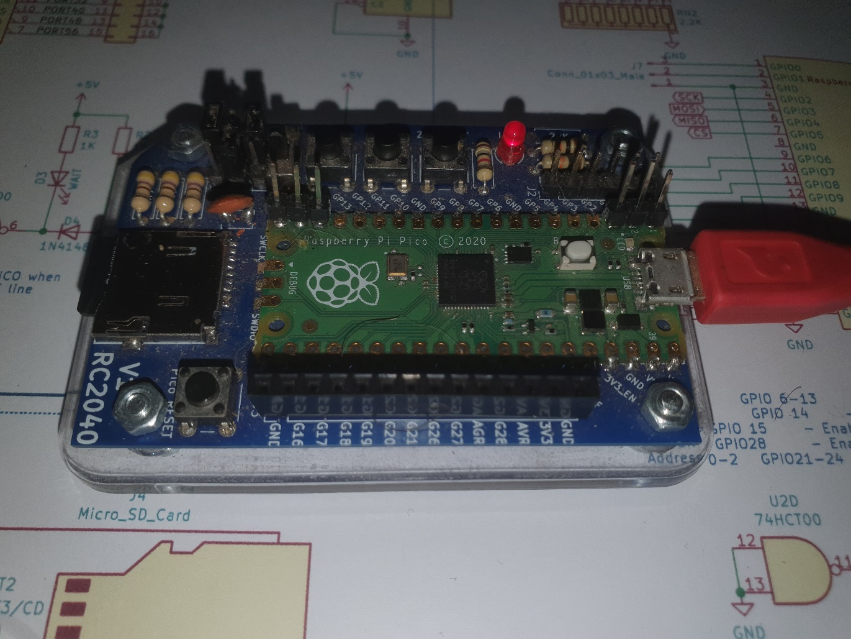

Start? Is displayed in Terminal

On your PC, Close your terminal editor and Go to the directory With the Python Files

To get a directory listing of a CPM drive

Type LS-RC20xx.py COMPORT DriveLetter

For my setup

LS-RC20xx.py COM4 D

To Copy a file from the RC20xx

CopyFrom-RC20xx.py ComPort DriveLetter FileName

For my setup

CopyFrom-RC20xx.py COM4 D TESTMAND.BAS

To Copy a file to the RC20xx

CopyTo-RC20xx.py ComPort DriveLetter FileName

For my setup

CopyTo-RC20xx.py COM4 D TESTTEST.TXT

**Note: The destination file must not already exist on the RC20XX**

To remove a file from the RC20xx

RM-RC20xx.py ComPort DriveLetter FileName

For my setup

RM-RC20xx.py COM4 D TEST.TXT

To cat (type) a file from the RC20xx

CAT-RC20xx.py ComPort DriveLetter FileName

For my setup

CAT-RC20xx.py COM4 D TESTMAND.BAS

(RC2040 ONLY)

To return to Serial Console

EXIT-RC2040.py COmPort

For my setup

EXIT-RC20xx.py COM4

RC2040 LED off

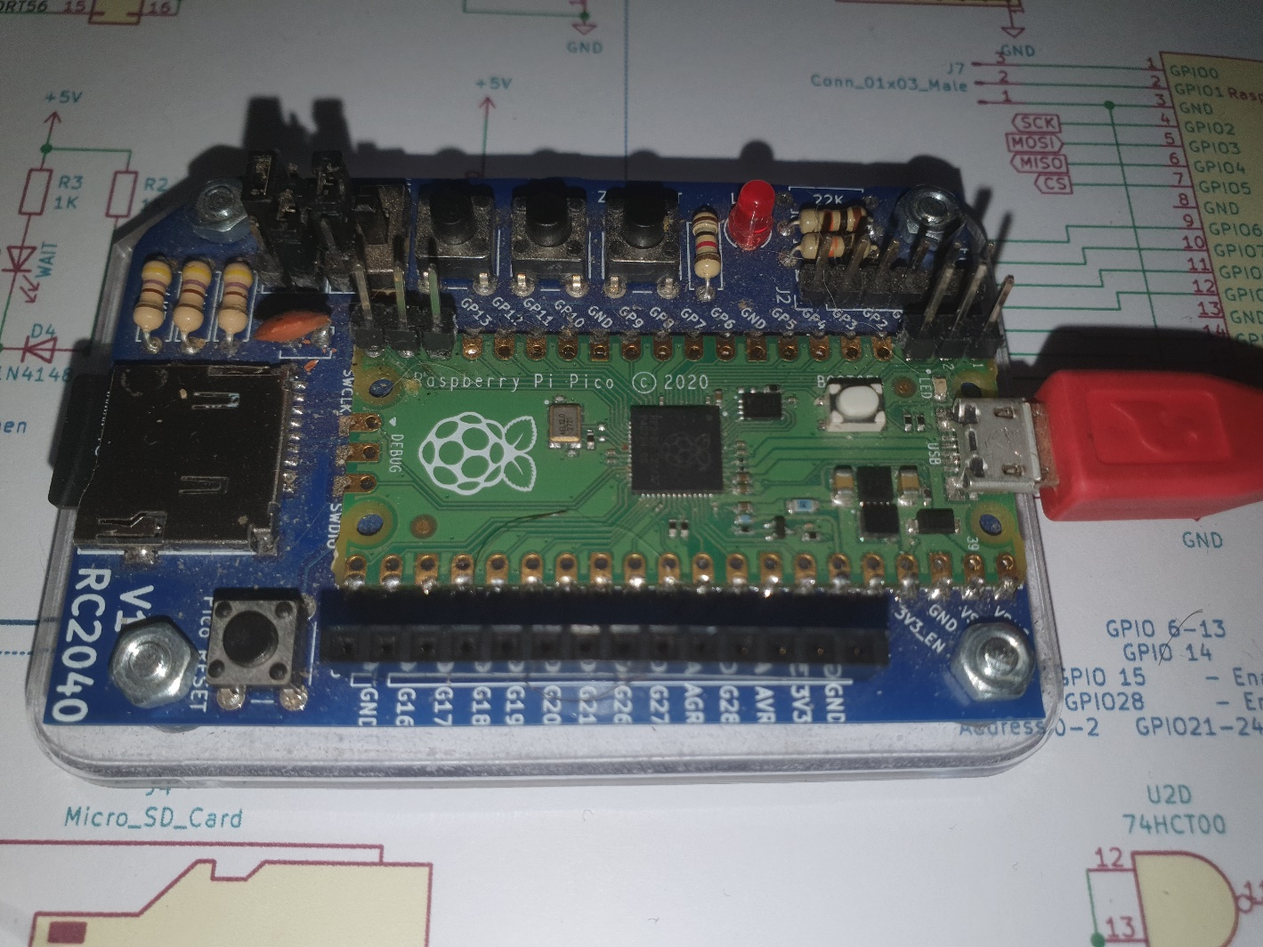

And if you reconnect your terminal you are back to the console

New

Program the RC2040 with a binary file.

After clicking the button.

Run the Python script

Program-RC2040.py COM4 0000 24.bin

Where 0000 is the base Address and 24.Bin is a raw binary file.

Exit the FFS mode and your RC2040 has the new code at the address you specified.